# CHAPTER ONE

**INTRODUCTION**

## 1.1 BACKGROUND OF SIWES

## Prior to the inception of the Student Industrial Work Experience Scheme (SIWES), a growing concern prevailed among industrialists regarding the readiness of graduates from higher education institutions. They believed that these graduates lacked the necessary practical background essential for employment in various industries. Consequently, employers held the view that the theoretical education provided by higher institutions did not align with the practical requirements of the labour market.

## In response to this pressing issue, the Industrial Training Fund (ITF) took a proactive step by establishing the Student Industrial Work Experience Scheme (SIWES) in 1973. SIWES emerged as a mandatory Skills Training Programme aimed at addressing the deficiency in practical skills among Nigerian graduates from tertiary institutions. Its primary objective was to bridge the gap between theoretical knowledge and the practical competencies necessary for successful employment within the industrial sector.

## 1.2 HISTORY OF THE SIWES PROGRAM

In 1973, The Industrial Training Fund (I.T.F) established the SIWES program. In 1974, it was officially presented and approved by the Federal government. However, the ITF withdrew from the program due to financial constraints in 1978. So in 1979, the National Universities Commission (NUC) and the National Board for Technical Education (NBTE) took over the management of the program.

In November 1984, from the federal government, the management and implementation of SIWES were handed back to ITF. In July 1985, ITF officially took charge of the scheme while the federal government took care of the funds.

Before the scheme was established, Nigerian industrialists expressed concerns that graduates lacked proper practical skills for employment in industries.

Furthermore, the theoretical aspects of education in universities didn’t match the requirements of employers in the labour market. So the industrialists called for the creation of a program that would allow students to garner the required practical skills they’d need to increase their chances of getting employed.

## 1.3 LOCATION OF THE ORGANIZATION

The Headquarters of Industrial Training Fund is located along Miango Road, P.M.B 2199 Jos, Plateau State

## 1.4 MANDATE OF THE ORGANIZATION

To equip students with the necessary practical knowledge and technical skills for self-employment and effective involvement in Nigeria's industrial growth.

## 1.5 STRUCTURE OF THE ORGANIZATION

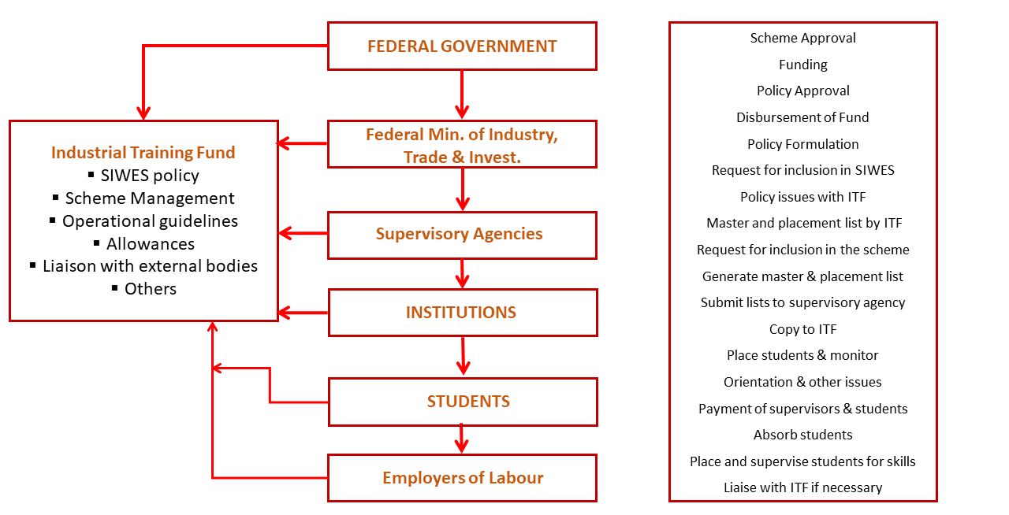

Figure 1.1: Shows the Structure of ITF

# CHAPTER TWO

**THE ORGANIZATION /INDUSTRY**

2.1 LOCATION OF THE ORGANIZATION

Neo Cloud Technology is situated at Suite C30 & 31, M.I.B Plaza, 1st Avenue, Gwarinpa Estate 900108, Gwarinpa.

2.2 HISTORY OF THE ORGANIZATION

Neo Cloud Technologies is a multi-product IT firm that provides creative and technology services across various sectors.

In the fall of 2017, Neo Cloud recognized a need in the industry for an innovative IT consulting firm that prioritized the needs of their clients. They’ve since then expanded to a team of over 25 employees, all of whom are dedicated to implementing full-stack solutions for Digital Transformation.

Neo Cloud also largely focuses on the education aspect of tech, training students all across the globe that are looking to get into tech. The company has trained over 2000 Nigerians in areas such as Cloud computing, Web development, Backend Development, Graphics Design, Data Analysis and so on.

Neo Cloud Technologies has over 20 certified instructors that are highly skilled at training people and taking their various skill levels from beginner to expert.

2.3 MANDATE OF THE ORGANIZATION

**MISSION**

To constantly exceed customer expectations by understanding their business needs and providing complete IT solutions.

**VISSION**

Neo Cloud Technologies belongs to a specialised niche or business, yet it is far from alone. With the appropriate innovation, we will be able to give something unique to our customers, making their brand stand out in the market and making it extremely easy for them to grow their income.

Talented, forward-thinking individuals want to work with forward-thinking organizations. Because the firm has a history of innovation, Neo Cloud Technologies is designed to attract anyone who is going to build the next great thing. We foster and develop innovators because they want to be challenged and pushed to innovate on a regular basis.

2.6 ORGANIZATIONAL STRUCTURE

  

**Anthony Ojei Sharon Omolegbe Jerry Brown**

Head - Digital Marketing Manager Head - Visual Communications

 

**Brown George Godstime Edet**

Head – Training & Research Head – Software Engineering

Figure 2.1: Shows the Head of the various departments

# CHAPTER THREE

**SIWES ACTIVITIES**

3.1 INDUSTRIAL WORK

During my 7 months of Internship experience at Neo Cloud Technologies, I was able to learn a lot of new things and gain a first-hand experience on how a real world tech job would be like.

I worked mainly with the cross platform mobile app building tech stack called Flutter as that was the technology I was required to work with mainly at the company. But even though I worked with Flutter mainly, I was able to also cut across an array of equally interesting technologies and ended up building some simple applications, such as:

* My Portfolio Website
* A Note Taking Application
* A School Management System Mobile App (Still in development…)

3.2 PORTFOLIO WEBSITE

I was able to rebuild my portfolio website using Next.JS, Framer Motion and Tailwind CSS. I got the chance to learn all these technologies during my time at the company. Some of the features I was able to implement in this portfolio are as follows

* Smooth navbar selection (using framer motion)
* Page Reveal (using framer motion)
* Light and Dark Mode (using TailwindCSS)
* Messaging (using Twillio)
* State Management (using Zustland)

I got to deploy the application on vercel and got a free domain as you can tell from the domain name with the .vercel.app extention

**Link:** <https://chukwudaniel.vercel.app/>

**Old Portfolio Link:** <https://chukwudaniel.netlify.app/>

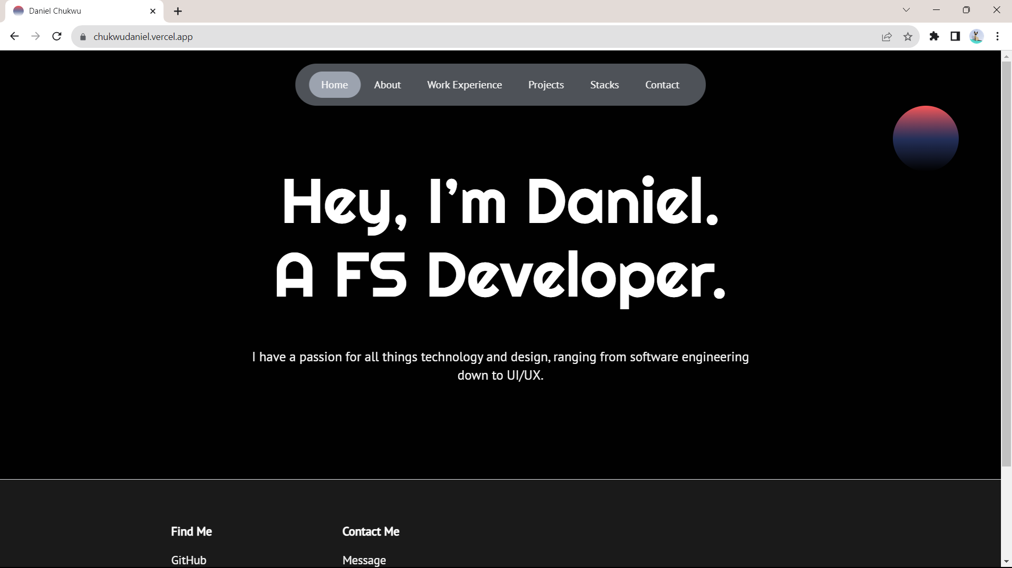

Figure 3.1: Portfolio Home Page

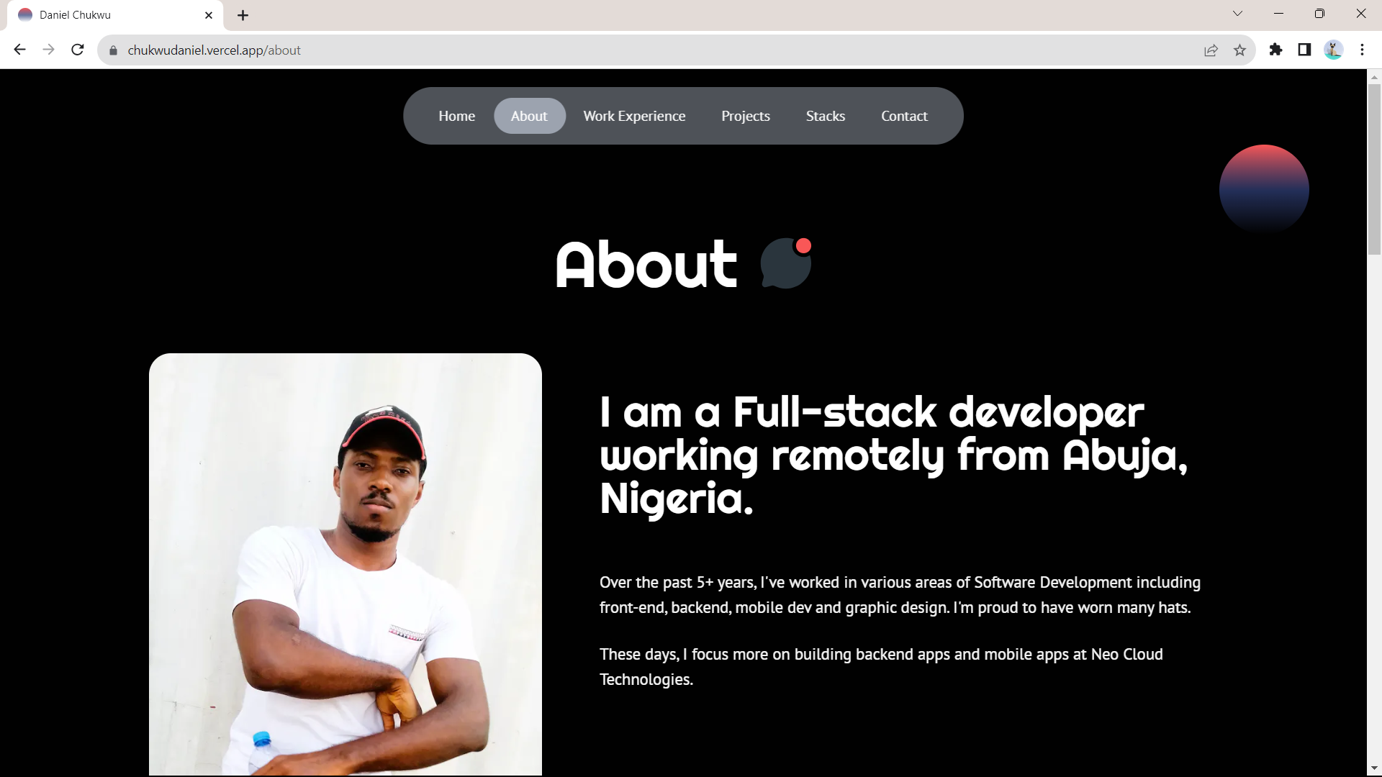

Figure 3.2: Portfolio About Page

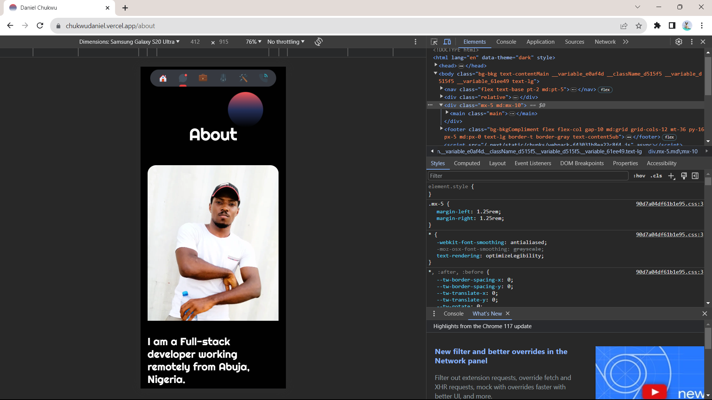

Figure 3.3: Portfolio About Page Mobile View

3.3 TAKE NOTE (A NOTE TAKING APPLICATION)

I always wanted to create an application that had a different feel to note taking, I was able to achieve this during the SIWES program. Unlike the portfolio website, this note taking application required a backend and a database to store the notes taken. The application was built using Typescript and Angular JS for the frontend and Spring Boot with Java for the backend, while I used PostgreSQL for the database.

This application took a month to complete and it had the following features.

* Authentication
* Notebook
* Note Taking (in NoteBooks)
* And CRUD operations for Notebooks and the notes in those notebooks

I deployed both the frontend and backend of this application on render.com

**Link:** <https://takenote-h0yd.onrender.com/>

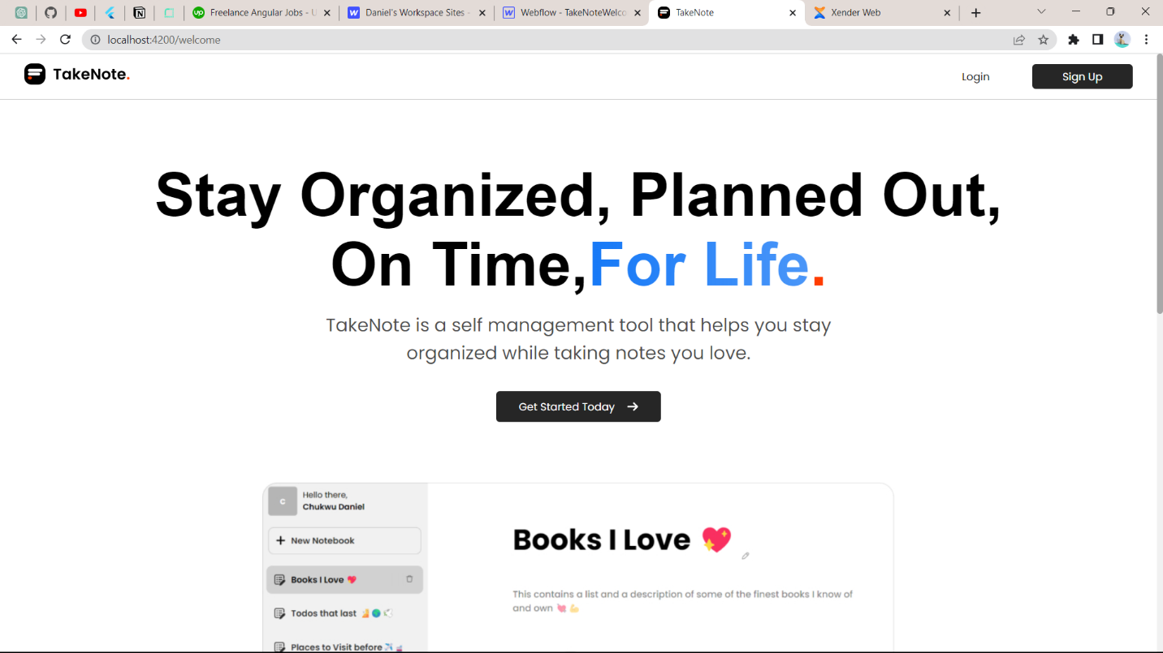

Figure 3.4: TakeNote Landing Page

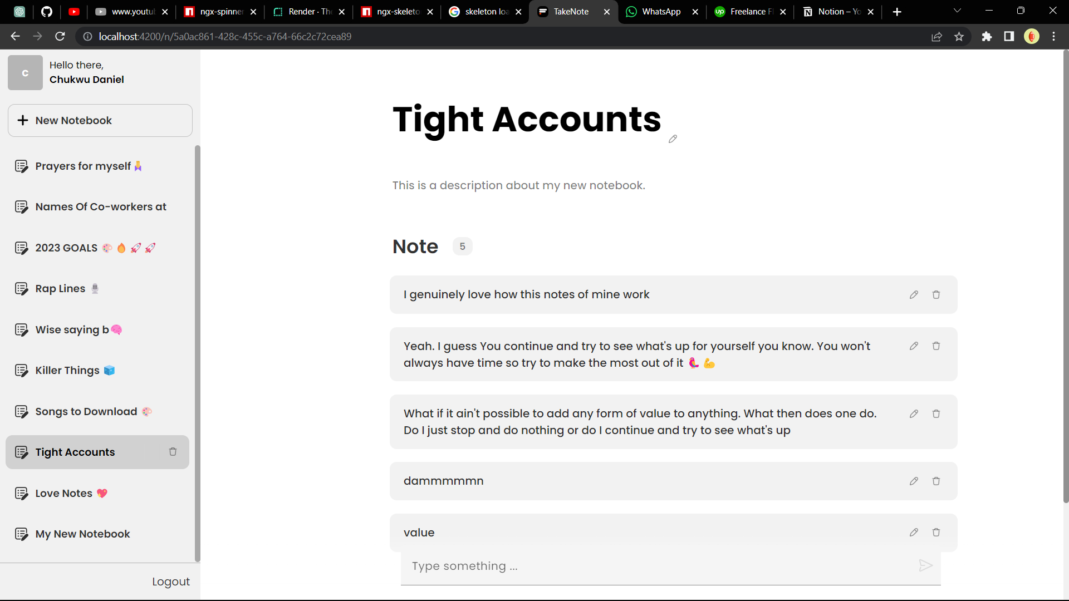

Figure 3.5: TakeNote otes Page

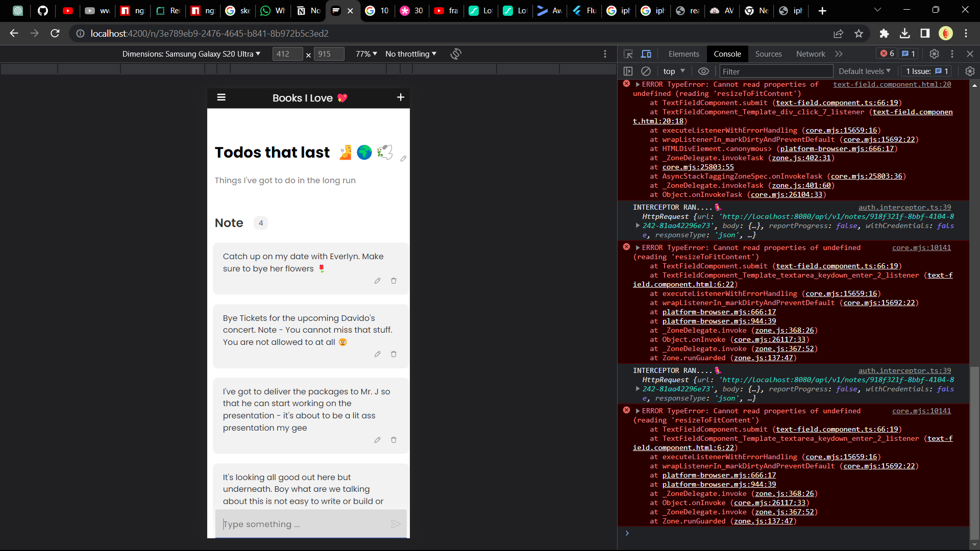

Figure 3.6: TakeNote Notes Page Mobile View

3.4 NEO CLOUD TECHNOLOGIES MOBILE APP

The first month I resumed at Neo Cloud Technologies I was tasked with building out a mobile application that helps the organization manage their Instructors and Students. I started building this application using Flutter, Node.JS, Typescript, GraphQL and MongoDB. For over 7 months I’ve been working on this application and I’m still yet to finish.

This application has a lot of features some of which are:

* Authentication & Authorization
* Roles
* Search
* User Profile
* Settings
* Faculties
* Classes
* Class Modules
* Class Schedules
* Class Instances
* Classwork’s
* Class Modules housing multiple Class Schedules
* Light and Dark Mode
* Uploading of Images
* Clean Architecture
* State Management Using Bloc
* Followed the TDD Approach to Software Development

**GitHub Link:** <https://github.com/danielchukwu/neocloud-learning-admin-mobile>

**Figma Design**

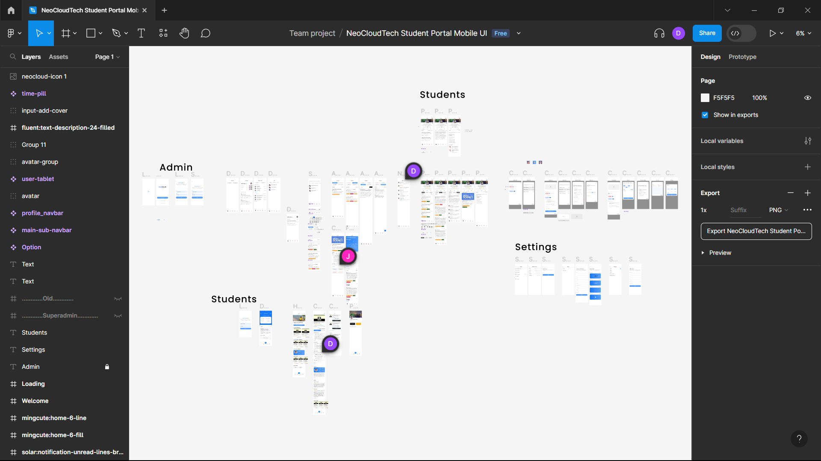

Figure 3.7: All pages of figma design

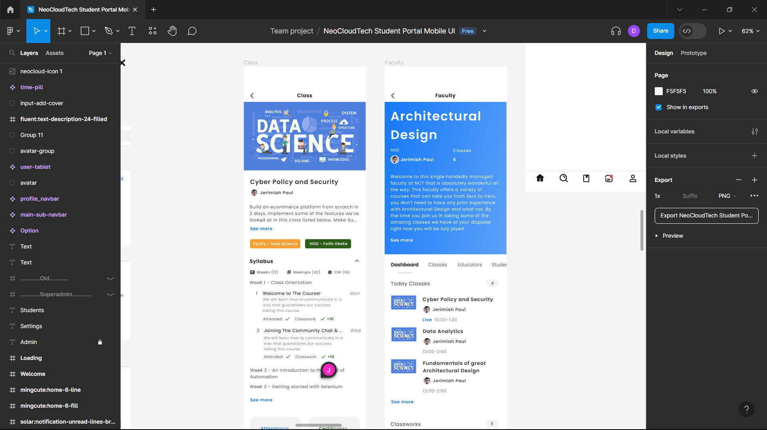

Figure 3.8: Class and Faculty pages of figma design

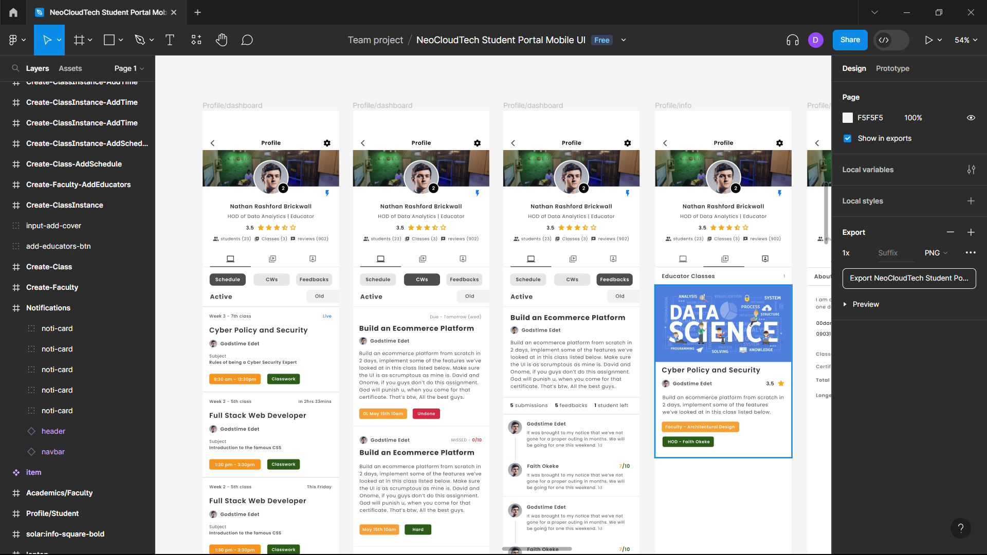

Figure 3.9: Profile Pages of figma design

**Db Design**

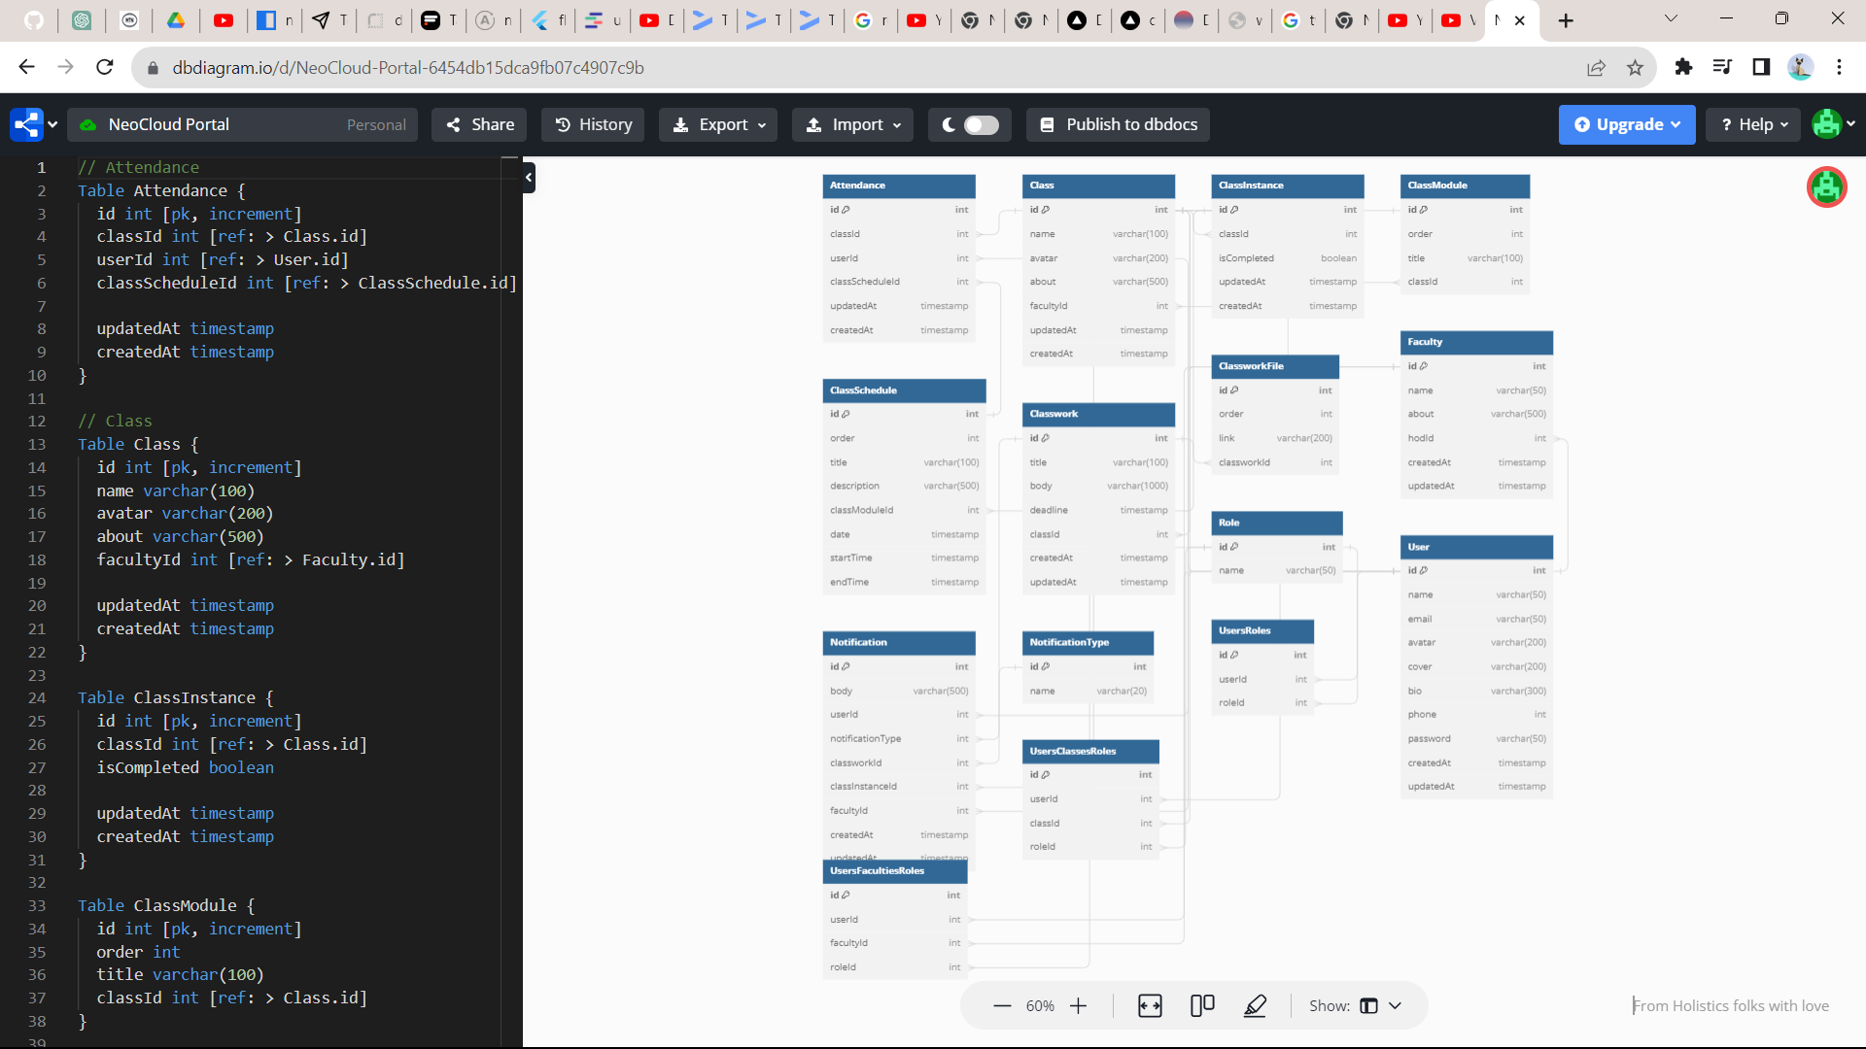

Figure 3.10: Neocloud Mobile App Database Structure

**Screenshots**

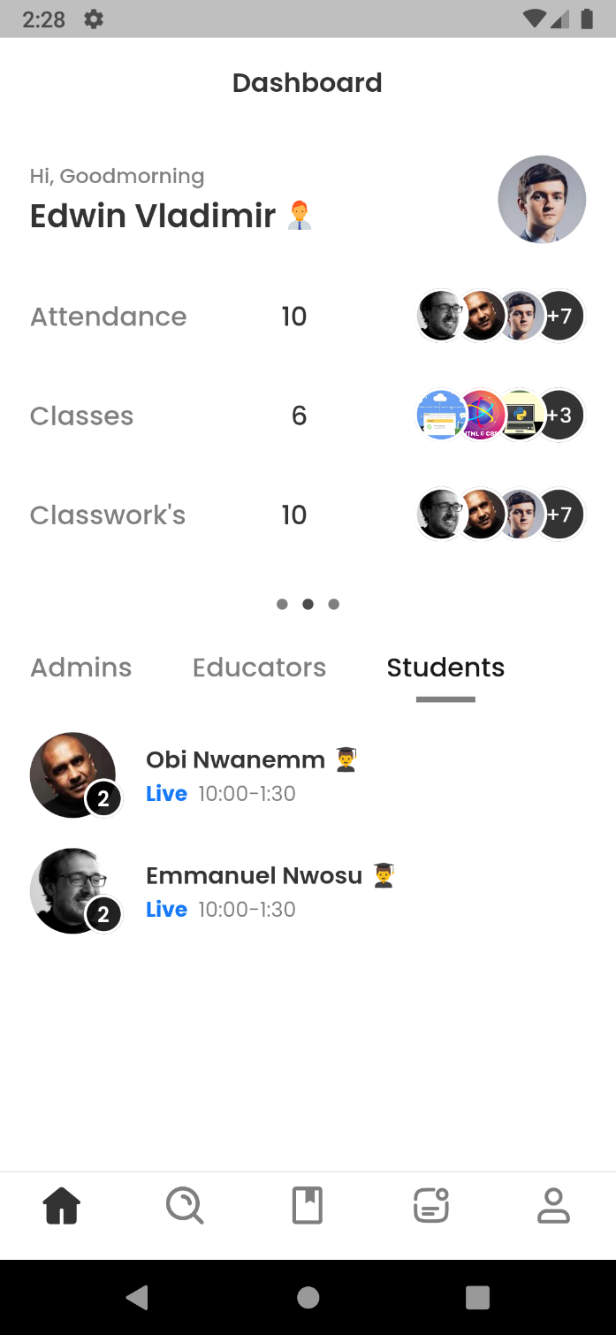 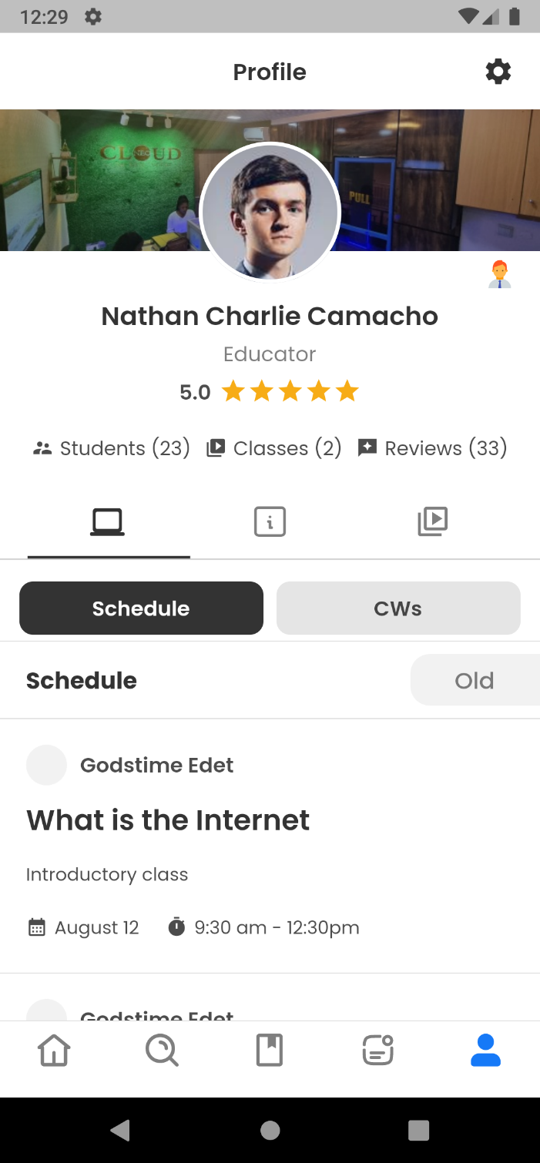

Figure 3.11: Neocloud Mobile App Dashboard and Profile Screen

**Development Screenshot**

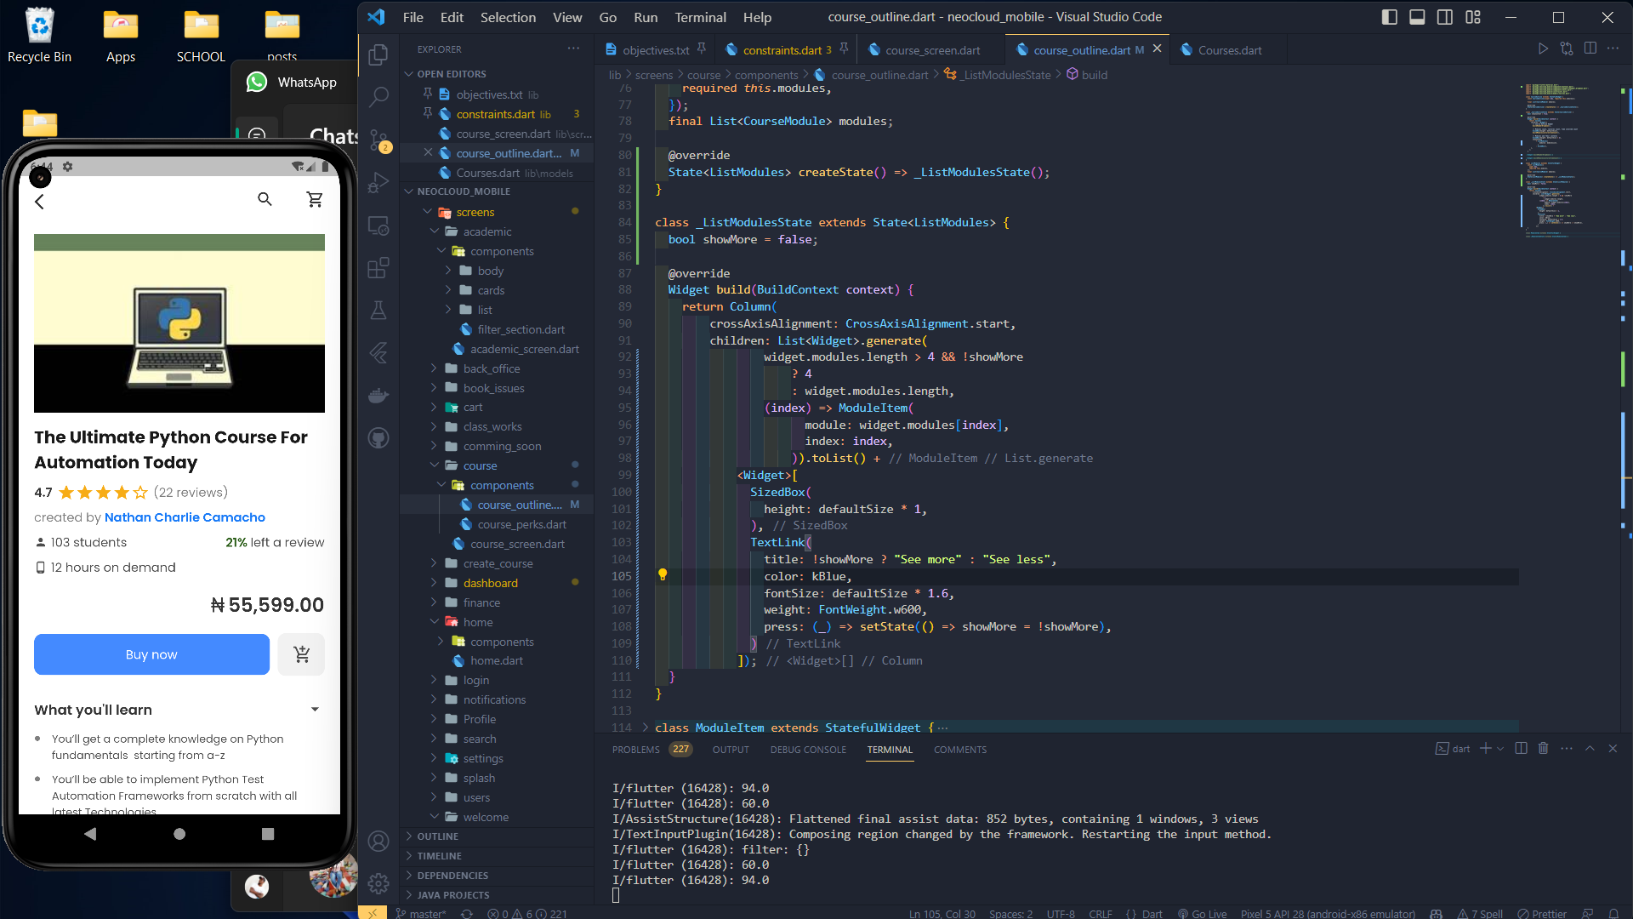

Figure 3.12: Neocloud Mobile App Course Screen

# CHAPTER FOUR

**SUMMARY, RECOMMENDATION, CONCLUSION**

4.1 SUMMARY

During my time in the program, I had the privilege of interacting with a multitude of exceptional individuals who generously shared their knowledge and provided invaluable mentorship. Their guidance played a pivotal role in shaping my understanding of the industry and allowed me to gain first-hand insights into contemporary trends and real-world operations.

These interactions not only enriched my knowledge but also provided me with a deeper appreciation of how things truly function within the field. The experience of witnessing industry professionals in action, alongside their willingness to impart their expertise, significantly accelerated my learning curve.

I am immensely grateful for the opportunity to learn from such accomplished mentors and for the exposure to the dynamic and ever-evolving landscape of the industry. Their contributions have not only broadened my horizons but have also equipped me with a practical perspective that will undoubtedly serve me well as I progress in my career.

4.2 SIWES CHALLENGES AND RECOMMENDATIONS

The Student Industrial Work Experience Scheme (SIWES) program, though highly advantageous, is not without its share of challenges. Here, I outline some of the challenges I personally observed and encountered during my seven-month internship.

**Lack of Adequate Placement Opportunities:**

* Challenge: Difficulty in securing suitable industrial placements for all students.
* Recommendation: Collaborate with more industries and organizations to expand placement options. Establish a centralized database for available placements.

**Inadequate Monitoring and Evaluation:**

* Challenge: Limited supervision and evaluation of students during their SIWES.
* Recommendation: Implement regular on-site visits and progress assessments by designated supervisors. Establish clear reporting mechanisms for both students and employers.

**Mismatch of Skills and Learning Objectives:**

* Challenge: Students may not always acquire the intended skills during their SIWES.
* Recommendation: Align the SIWES curriculum with industry demands. Regularly update learning objectives to reflect current industry trends.

**Logistical Challenges:**

* Challenge: Issues with transportation, accommodation, and safety during SIWES placements.
* Recommendation: Provide logistical support, including transportation and housing options, to ensure the safety and well-being of students.

**Mismatch of Student Skills and Employer Needs:**

* Challenge: Employers may not always find SIWES students adequately skilled.
* Recommendation: Facilitate regular communication between educational institutions and employers to ensure that students receive training aligned with industry requirements.

**Limited Post-SIWES Transition Support:**

* Challenge: Graduates may struggle to transition into full-time employment after SIWES.
* Recommendation: Establish career counseling services and job placement programs to assist SIWES graduates in finding suitable employment opportunities.

4.3 CONCLUSION

In conclusion, my experience with the Student Industrial Work Experience Scheme (SIWES) has been truly transformative and enlightening. Over the course of my internship, I had the opportunity to bridge the gap between theory and practice, gaining practical insights into my field of study that classroom learning alone could not provide.

I met inspiring mentors who not only guided me professionally but also instilled in me a passion for continuous learning. The challenges I faced during my SIWES journey served as valuable lessons, strengthening my problem-solving abilities and resilience.

Moreover, this experience has reinforced the importance of industry-academia collaboration in nurturing well-rounded and job-ready graduates. SIWES serves as a vital link between educational institutions and the professional world, preparing students for the demands of their future careers.

As I look back on my SIWES experience, I am grateful for the knowledge, skills, and network I have acquired. It has not only prepared me for the challenges of the workplace but has also ignited a lifelong commitment to growth and excellence in my chosen field. I am excited to carry these lessons forward as I embark on the next phase of my academic and professional journey

4.4 REFERENCES

1. <https://techneo.ng/knowledge-ninjas/#leadership>

2. <https://smartbukites.com/the-history-of-siwes-in-nigeria>

3. <https://dbdiagram.io/d/NeoCloud-Portal-6454db15dca9fb07c4907c9b>

4. <https://chukwudaniel.vercel.app>

5. <https://takenote-h0yd.onrender.com>

6. <https://github.com/danielchukwu/neocloud-learning-admin-mobile>